- What is an exception?
An exception is a run-time error, an abnormal condition that arises at runtime. When JRE encounters a run-time error, it creates an exception object and throws it. If the exception object is not caught and handled properly, the JRE will display an error message and terminates the program.

- What is exception handling and why is it done?
The process of catching the exception object thrown by the JRE and displaying an appropriate message. It is done to:
- Prevent program from terminating abruptly
- Easily identify errors and handle them
- Report errors meaningfully

- Java exception class hierarchy
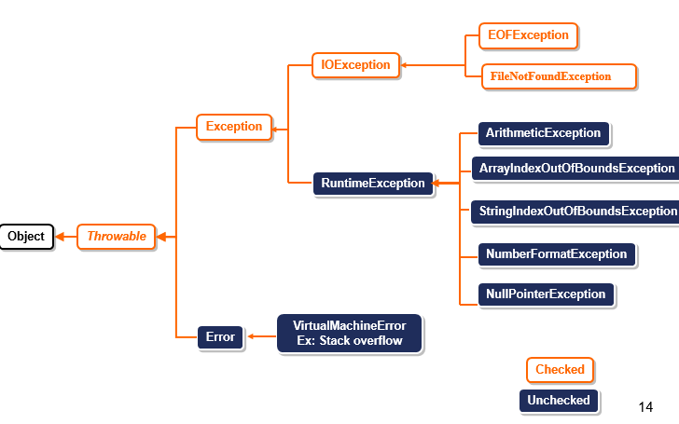

- IOExceptions:-
  - The Subclasses IOException represent exceptions that can occur during the processing of file input and output statements.
- RuntimeExceptions:-
  - The subclasses of RuntimeException represent exceptions that occur during the processing of a program (other than file i/o statements).

- What are checked and unchecked exceptions
Checked – Exceptions that are checked by the compiler whether they are handled or not. Compiler gives an error if the exceptions are not handled by try, catch.
Unchecked – Exceptions that are not checked by the compiler whether they are handled or not.

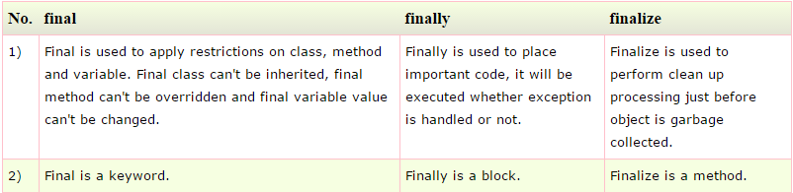
- Difference between final, finally and finalize

- What is try-with resource
The try-with-resources statement is a Java feature ensures that resources are automatically closed after they are used. This can help to prevent resource leaks and other problems. The try-with-resources statement takes a block of code as its argument. The block of code can contain any number of resources, which will be closed in reverse order of their opening

- What are streams?
A stream can be defined as a sequence of data. There are two kinds of Streams
InPutStream − The InputStream is used to read data from a source.
OutPutStream − The OutputStream is used for writing data to a destination.

- What are standard streams?
Standard Input − used to feed the data, usually from keyboard. Represented as System.in
Standard Output − used to output the data produced, usually a computer screen, Represented as System.out
Standard Error − used to output the error data, usually a computer screen. Represented as System.err.

- Differentiate character and byte streams
Byte streams handle raw binary data, typically in the form of bytes (8 bits). They are used for reading and writing data at the byte level and are suitable for handling binary data, such as images, audio files, and executable files. Byte streams are represented by classes ending with InputStream or OutputStream.
Character streams handle textual data and provide higher-level abstractions for working with characters and strings. Character streams are suitable for reading and writing text files, where characters are represented using a specific character encoding (e.g., UTF-8, ASCII). Character streams are represented by classes ending with Reader or Writer.

- What is random access file?
RAF permits nonsequential, or random access to file’s contents. With RAF, reading and writing of data at any location is possible using seek function. Methods of this class usually throw EOFException (end of file exception).
There are 4 access modes:
r - Creates the file with read mode; Calling write methods will result in an IOException.
rw - Creates the file with read and write mode.
rwd - Creates the file with read and write mode - synchronously. All updates to file contents are written to the disk synchronously.
rws - Creates the file with read and write mode

- What is enum?
Enumeration is a list of names constants. It is a data type that contains fixed set of constants. Enum constants are static and final implicitly.
All enumerations automatically contain two predefined methods:
- values( ) : returns an array that contains a list of the enumeration constants
- valueOf( ): returns the enumeration constant whose value corresponds to the string passed

- What are type wrappers? Why do we do autoboxing?
Type wrappers are wrapper classes that encapsulate primitive data types. The process of encapsulating is called autoboxing. We do autoboxing to work with generic classes. All collection framework classes, which are generic classes, don’t support primitive classes, therefore primitive values need to be mutually converted to corresponding wrapper classes.

